Cesar

Segmentation And Reassembly Specification

2008/03/06
rev. A2

© 2007 SPiDCOM Technologies, ALL RIGHTS RESERVED

SPC, SPR, SCR, SVR are trademarks of SPiDCOM Technologies.

All other products or services mentioned herein may be trademarks of their respective owners.

Notice: No part of this publication may be reproduced or transmitted in any form or by any means, electronic or mechanical, including photocopying and recording, or stored in a database or retrieval system for any purpose without the express written permission of SPiDCOM Technologies.

SPiDCOM Technologies reserves the right to make changes to this specification at any time without notice and assumes no responsibility for its use. This specification contains the most current information available at the time of publication.

Introduction

Forewords
This document contains Cesar Segmentation And Reassembly Specification. Its goals are :
- Segmente packet provided by the Convergence Layer into PB to be send over the PWL.
- Reassembly MPDU packet to reconstitute the Mac Frames it contains.
- Expire the PBs and MFSs
- Drop non encrypted data packets.
- Inform the Control Plane when MMEs has been received not encrypted.

Table of contents
1.Introduction 2
1.1.Forewords 2
1.2.Acronyms 4
2.General Description 5
2.1.General Features 5
2.2.Titre 2 5
2.2.1.Titre 3 5
2.2.1.1.Titre 4 5
3.References 6
4.History 7
5.Internal History 8

Acronyms
SAR : Segmentation And Reassembly
CP : Control Plane
MF : Mac Frame
PB : Phy Bloc
MFS : Mac Frame Stream

General Description
The SAR is present in the Mac layer, its job is to segment and reassembly packet comming from the PWL to the CL or in the other way from the CL to the PWL.
It realize some other jobs too like
- Providing and sending the Beacons.
- Expiring the unuse MFS ( thoses which has an unactivity since 1 second and can expire )
- Expiring PBs, those which are too old to be reassemblied.
- Verify if the STA is authenticated, if the STA receives a crypted PB, then it is authentified.

The SAR is a thread, its priority is lesser than the PBProcessing.
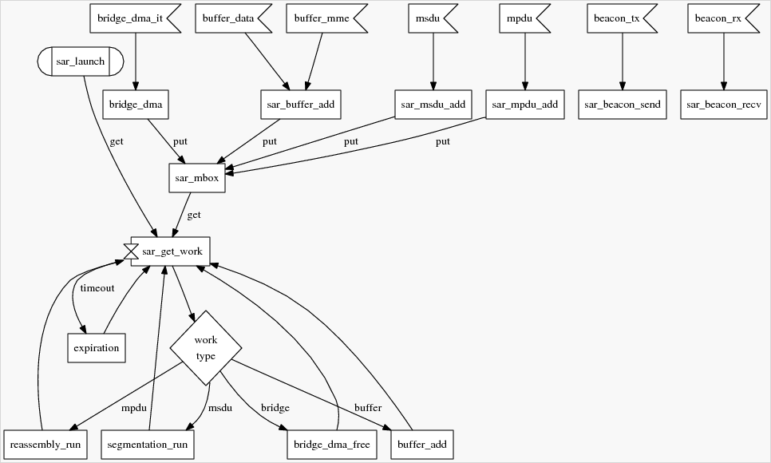Figure 1: Sar overview

The SAR thread consist on a loop which wait for a delay computed on the next expiration date ( date in the MFS of the PBs ).

Segmentation ( TX )
The segmentation process consists to allocate the PBs necessary to stock the msdu in it and create the job for the bridge DMA to copy the data into the PBs.

The Segmentation process constists in two main steps :
- Verify the msdu ats.
- Segmentate the MSDU.

The first step consists in verifing the ATS provide when it has a MSDU to segement. The objective is to drop the packet if it does not have the time to be segmented.

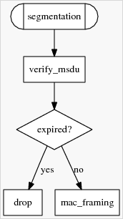Figure 2: Segmentation procedure.

At the end of this processdure, two cases are possible :
- The msdu has expired and the SAR inform the CL that the segmentation has been done.
- the PBs are in a job to be filled by the bridge dma. Once this is done, the bridge dma raise an interruption and a bridge message will be inserted in the SAR mailbox. Only at this moment the SAR will inform he pbproc that new segments are available and can be send over the PWL.

Mac Framing
The Mac Framing procedure has for job to allocate the quantity of PBs necessary to contain the MF.
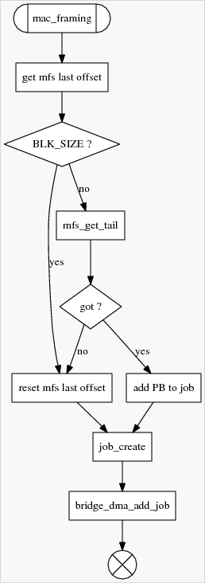Figure 3: Mac Framing process.
Note : The MFS is provide at the same time as the MSDU to segment.

Get MFS last offset
It is present only in the tx MFS. It informs where the the bridge DMA can start to write a data in the last PB of the MFS. This value is in a range going from 0 to BLK_SIZE – 1.
To avoid a current possession of the last PB of the MFS by the PBPROC and the SAR when the PBPROC wants to send a short PB, this value is put to BLK_SIZE. By this way the segmentation procedure will not request the last PB of the MFS from the PBPROC because it knows that there is no more space available in it.
A second test on the available space in the PB will be done in the “ create_job “ function.

MFS get tail
This function allow the segmentation module to take the last PB of the MFS if the PBPROC is not using it. For that this function is in the PBPROC context and return the last PB in the MFS if it possible i.e. the PBPROC is not sending it.

Add PB to job
This functionality also put the last PB in the bridge job, if the PB could be get from the MFS.

Create job
This function fill the job with the correct value and allocate the PBs necessaries to stock the msdu data.

Bridge DMA add job to process
It consists to put the job previously created to the bridge DMA list of jobs to process.
This list is useful for the transmission, in a first part it allows the segmentation to prevent the PBPROC that some segments are available. In a second part it allows the SAR to release the job previously created.
For the transmission, it allows the SAR to inform the upper layer which had request the transmission of the msdu, to know that the buffer used to bridge the msdu is available for a future use.

Reassembly ( RX )

Description
The reassembly function corresponds of a follow up functions :
- PB pool refill
- MPDU RX process
- MFS process
- Transmit data.

It allocates the same quantity of PBs contained in the MPDU to give it to the PBPROC, it is the “ PB_pool_refill “ function.
Then the MPDU is process by the “ MPDU_RX_process ”, this function will verify the validity of each PB and insert it into the associated MFS.
The next step corresponds to process the MFS to verify if at least a MF can be reconstitute with the PBs received.
The last one will try to insert as many jobs as it can in the bridge DMA to send it to the upper layers.
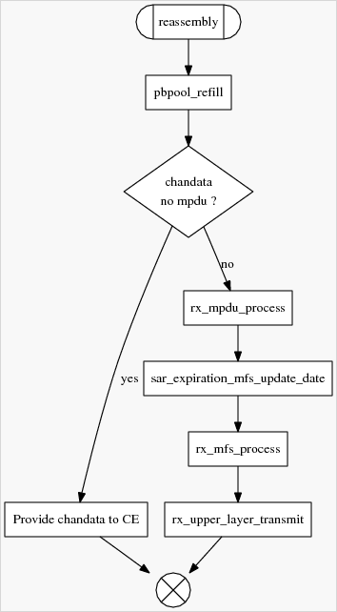Figure 4: Rx MPDU process

PB pool refill
The SAR allocates a new quantity of PBs equivalent of the quantity received in the MPDU which is being processed.
This Pb pool is manage by the PBPROC, the job of the SAR is only to allocate new PBs and give the chain to the PBPROC.

Process MPDU
It process the MPDU, this activity consists in various steps.
- Send the measures of the chain to the Channel Estimation.
- verify the validity of each PB.
- verify the expiration date of each PB
- Resize the MFS if necessary
- Insert the PB in the MFS.

Process MFS
This activity consists to take the MFS associated with the MPDU and process it in order to reconstitute as many Mac Frames as possible. Those MFs will be put in a buffer list to be bridge in the future.

UL transmit
Once the jobs had been created and stocked in the right job buffer list, a buffer is needed by the bridge to reconstitute the MF contained in a job.
The SAR contains a symmetric mechanism for the DATA and for the MME. It consists in a buffer address list and a job buffer list.
The buffer address list contains all the addresses given by the upper layer to reconstitute the MF in it.
The job buffer list contains the pending jobs which does not have a buffer to be processed.
When the two resources are available, the bridge takes the job and the buffer address and reconstitute the MF in the buffer with the data contained in the job descriptor.
Once it is done, the bridge sends an interruption to the SAR to release the job. The SAR inform the upper layer that the buffer contain a MF.
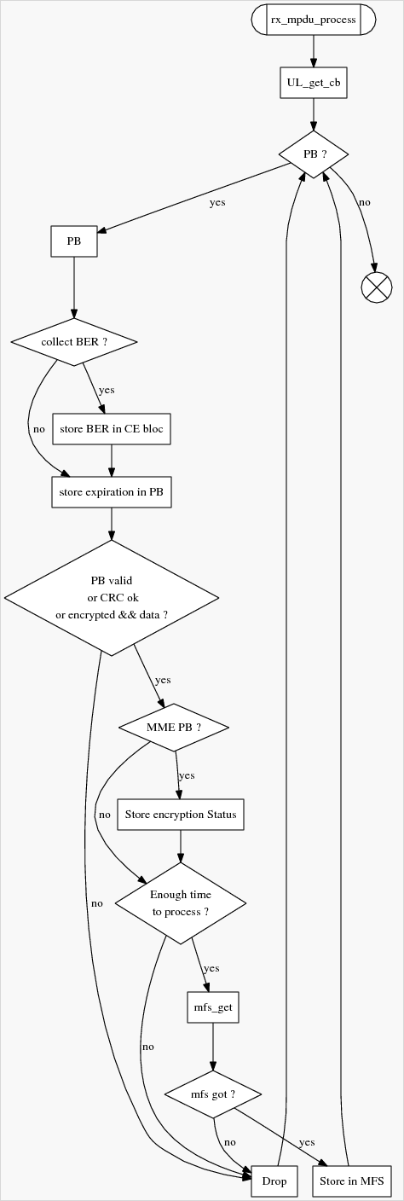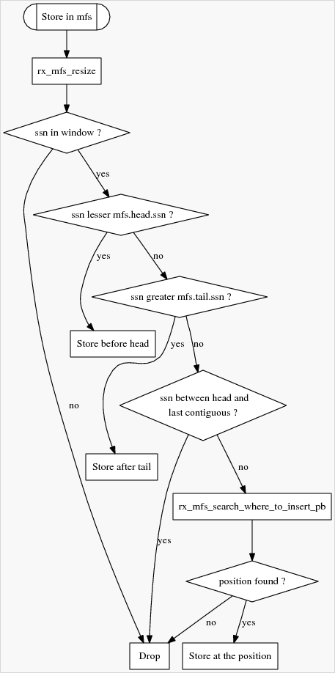
Figure 5 : Rx mpdu process.

Store in MFS
It consists in inserting the PBs from the rx_mpdu to the MFS associated.
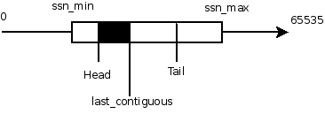Illustration 1: Schema of the MFS with its data

Illustration 1 represents the state of the MFS.
For the sort algorithm we have the following data to use :
- ssn_min : the minimum sequence number this MFS can receive from another STA.
- head : the pointer to the first PB in the MFS.
- last_contiguous : the last contiguous PB from the head.
- tail : the last PB in the MFS.

There are three zones where a PB can be inserted :
- between the ssn_min and the head
- between the last_contiguous and the tail
- between the tail and the ssn_min plus the window size i.e. the ssn max in the illustration.

Each PB have some conditions to verify to be inserted in the MFS :
- The ssn is in the MFS window size.
- Its ssn is not between the head and the last contiguous.
- Its ssn is not equal to the head, last contiguous and the tail.
If theses three conditions are not verified the Pb is released, and it restarts with the next one.

If PB's ssn equals the MFS ssn min : increments the MFS ssn_min. Add the PB to the head of the MFS.
If PB's ssn equals the MFS ssn_max : Add the PB to the tail of the MFS.
If PB's ssn lesser than the MFS head : insert it before the head.
If PB's ssn greater thant the MFS tail : insert it after the tail.
if PB's ssn is between the last contiguous and the tail, it will search the right place to insert it in the MFS chain.

Example :
The ssn_min of the MFS is 65500.
rx | 3 | 4 | 5 | 3 | 4 | 6 | 7 | 8 | 65530
MFS

At the start the MFS is empty, the first PB of the Rx is in the window size of the MFS so it will be inserted in the MFS.
The consequence is that the pointer of the MFS will point directly to this PB.
mfs->head == mfs->last_contiguous == mfs->tail.

rx | 4 | 5 | 3 | 4 | 6 | 7 | 8 | 65530
MFS | 3

For the two PB at the start of the Rx, the same processing will be done. Those two PBs are in the MFS's window size ans between the tail and the ssn_max i.e. the end of the window. So it will be inserted after the tail.

rx | 3 | 4 | 6 | 7 | 8 | 65530
MFS | 3 | 4 | 5

For the two following PBs in the Rx, they will be removed and freed from the memory because they are already in the MFS. The algorithm does not check to insert PBs which are between the head and the last_contigous, it will directly remove those PBs.

rx | 6 | 7 | 8 | 65530
MFS | 3 | 4 | 5

The three next PBs in the Rx will be inserted after the tail.

rx | 65530
MFS | 3 | 4 | 5 | 6 | 7 | 8

The last one is in the MFS's window size ans between the ssn_min and the head. It will be inserted before the head.

rx
MFS | 65530 | 3 | 4 | 5 | 6 | 7 | 8

Rx MFS Process

Detect and reconstitute
A Mac Frame has a length going from 62 Bytes to 1528 Bytes ( see Figure and section 12.3.2.1.1 page 663 of the HomePlug AV specification).
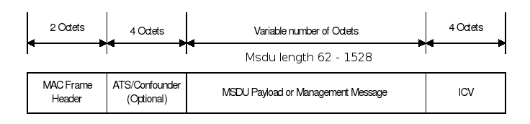Figure 5: Mac Frame header
A MF can be contained a most in four PBs, and a PB can contain at least a MF.
For example a PB can contain 7 complete MF and another one incomplete when all the MF are 68 Bytes long.

The unique information we have in the PB is a Mac Frame Boundary Flag, but it does not give the number of MF it contains. The only way to know the quantity of MF a PB contains, is to read in the Mac Frame Length and the Mac Frame Type in the MFH.
The MFL only give the length of the MSDU payload, but knowing the MF type it is easier to know the real length.
To find each MF in a list of PB it is necessary to read three data
- The MFT to know the type of the MF.
- The MFL to know the length of the payload.
- The MFBF to determine if there is a bound in the PB.
- The MFBO to know the address at which the MF starts.
In the specification there are four types of MF.

MFT | Description | Length
0b00 | Padding
0b01 | Payload alone | MFH + Payload + ICV  6 bytes + Payload
0b1x | ATS / Confounder with Payload | MFH + ATS/CFD + Payload + ICV  10 bytes + Payload

The padding indicates that there are no more MF in the PB. For the others by reading the data listed above it is possible to detect a MF.
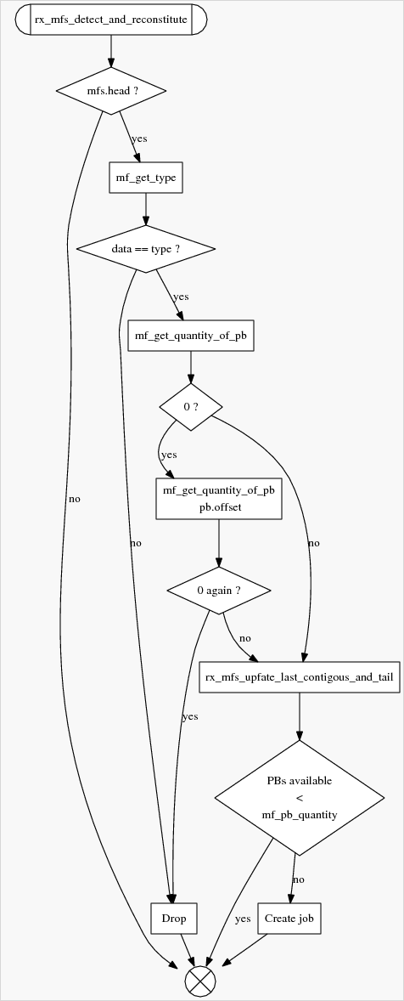Figure 6: MFS detect and reconstitute.

Bridge DMA Free
The bridge dma free head is a chained list containing all the job provided to the bridge dma ( tx, rx ). When the bridge dma finishs a job an interruption is raised and it will insert a message in the SAR mailbox. This allows a minium time elapse in the DSR function.

Once the SAR gets the message it will call the bridge_dma_free_head function which has for job :
- TX
  - Inform the upper layer when the MSDU has been sent.
  - Give back the buffer containing the MSDU.
  - Inform the PBProc that new segments are available.
- RX
  - It verifies the CRC error bit in the job.
    - CRC wrong. The buffer is kept by the SAR for a future reassembly.
    - CRC Right. The MF is provided to the upper layer.
  - Verify the encryption only for MME.
    - if all the PBs are encrypted, it puts the source STA as encrypted.
    - if at least a PB in the MF is encrypted, ut puts the source STA as encrypted.
  - The MSDU is provided to the upper layer.

Expiration
The expiration consists in releasing all the oldest PBs in a MFS or an inactive MFS.
To realise this job, a heap is use which puts in the root element the oldest element. This allows the PBs to be released if it can not be reassemblied, or to release a link if the MFS is not use for than a second.

See the Section 5.4.1.6.2 Receive buffer management.

Beacon
The beacon in the SAR are only functions API to send an receive beacons.

On a beacon RX. the callback function is called to deliver it to the CP.
On a becon TX, the CP provides the beacon and all the data necessary to send it. The SAR only call the correct functions in the PBProc to send it.

The beacons are actually provided on RX by the SAR to the Interface module, and on TX by the Interface module to the SAR.

References
REF1 :
File : N/A
revision

History

Revision | Date | Comments
B0 | 2006/09/01 | Creation

Internal History

Rev. | Date | Comments | Customer  Revision
A0 | 2007/07/20 | Etienne Chevreau (EC) :  - imported from POLUX-rel-3-9 ProductSpecification release A2,  - added :  - SLAVE_FOR_CABLE definition

