CP Conn

Cesar

11/03/2008

© 2007 SPiDCOM Technologies, ALL RIGHTS RESERVED

SPC, SPR, SCR, SVR are trademarks of SPiDCOM Technologies.

All other products or services mentioned herein may be trademarks of their respective owners.

Notice: No part of this publication may be reproduced or transmitted in any form or by any means, electronic or mechanical, including photocopying and recording, or stored in a database or retrieval system for any purpose without the express written permission of SPiDCOM Technologies.

SPiDCOM Technologies reserves the right to make changes to this specification at any time without notice and assumes no responsibility for its use. This specification contains the most current information available at the time of publication.

Introduction

Forewords
This document contains the connection module specification on the Cesar project. Its goals are :
- To expose how the connection are stored.
- To present the mechanisms of connection management.
All the informations contained in this document are extract from the Home Plug AV specification release 1.0.10.

Table of contents
1.Introduction 2
1.1.Forewords 2
1.2.Acronyms 4
1.3.Values 4
2.Connection Specification 5
2.1.Class Diagram 5
2.2.Information on the connections 6
2.3.Connection module classes 6
2.4.Creation of a connection 6
2.5.Release of a connection 9
2.6.Modification of a connection 9
2.7.Information of a connection 10
2.8.Test the validity of a connection 10
3.References 11
4.History 12
5.Internal History 13

Acronyms
ATS : Arrival Time Stamp
ATU : Allocation Time Unit
BLE : Bit Loading Estimate
CAP : Connection Access Priority
CCo : Central Coordinator.
CINFO : Connection Information
CID : Connection Identifier
CP : Control Plane
CSPEC : Connection Specification
FID : Field Identifier
GLID : Global Link Identifier
QoS : Quality of Service
QMP : QoS and Media access control Parameters
TDMA : Time Division Multiple Access
TXOP : Transmission Opportunity

Values
AllocationTimeUnit : 10,24 µs

Connection Specification

Class Diagram
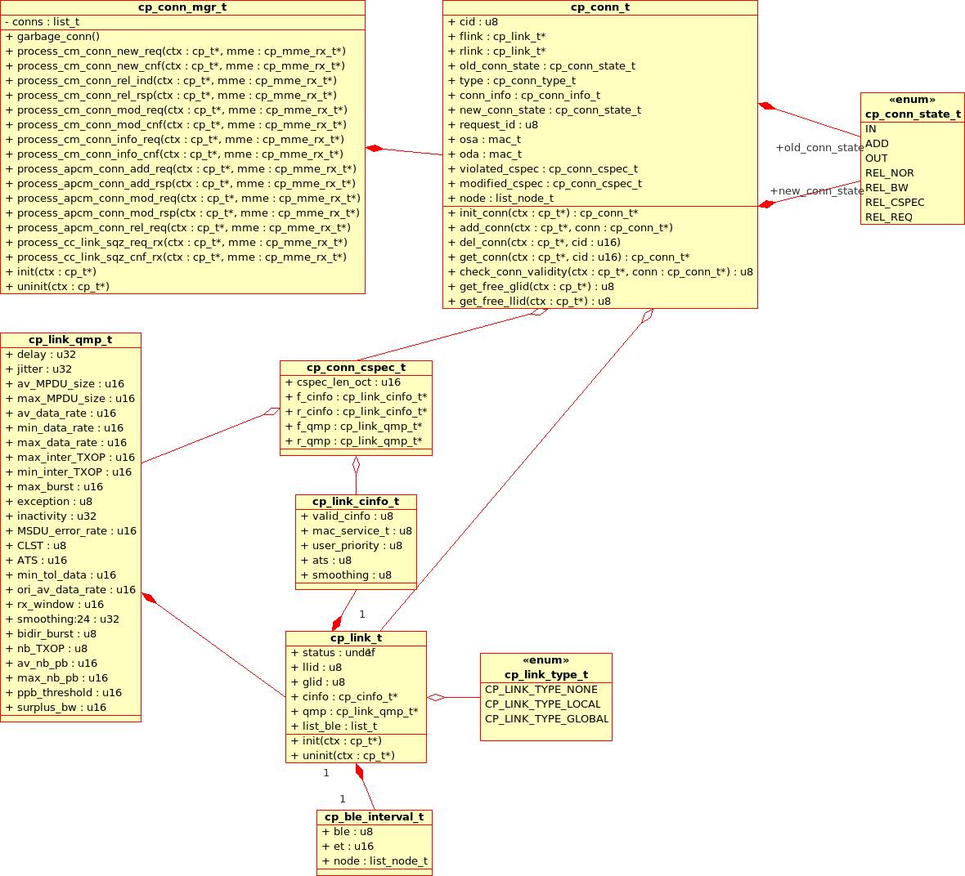Illustration 2.1.: Class diagram of the connection module

Information on the connections
The different type of LID :
Type of LID | Value
PLID : priority links (CSMA, connectionless links) | 0x00 - 0x03
LLID : Local links (assigned by the conn module) | 0x04 - 0x7F
GLID : Global links (assigned by the CCo module) | 0x80 - 0xF7
GLID specific : CFPI | 0xFC
GLID specific : Discover | 0xFD
GLID specific : Shared CSMA | 0xFE
GLID specific : Local CSMA | 0xFF

Assignment of LIDs :
Local links : Originating STA shall determine directly the LLID-F and the terminating STA the LLID-R.
Global links : Assigned by the CCo.
Assignment of the CIDs :
Each connection has a globally unique CID in the network.
A CID is 16 bits : The 8 bits of the TEI of the originating STA with the 8 bits of the LLID-F (even if there is no forward link the STA shall always create a LLID-F for CID creation purpose).
The CID won't change when the GLID is assigned.

Connection module classes
Connection manager :
The connection manager is part of the control plane context. It holds the list of connections. It will receive the MME concerning the connection module and react to them.
Connection :
The connection class has the function that controls the connections. It can add, delete, test, modify a connection. It has access to the links related to its connection.
Link :
The link class has the functions that controls the memory taken by the links. The BLEs, the CSPEC and CINFO have to be stored, initiated and uninitiated properly. The link class regroup all the data of a specific link.

Creation of a connection
The request is initiated by the HLE.
The HLE gives a CSPEC, the destination STA's MAC address and Classifier rules.
The connection module study the CSPEC to determine the number of links necessary and their types (global or local links).
Then the connection module send a request to the terminating STA to start the creation of the connection. A LLID-F is chosen.
The Connection identifier shall be initiated using the STEI for the 8 firsts bits and the LLID-F for the other 8 bits.
If a global link is necessary it shall request one to the CCo (see CCo conn document). During the time of the request a Global Link is used for the connection to transmit, it is identified by the STEI and the LLID.

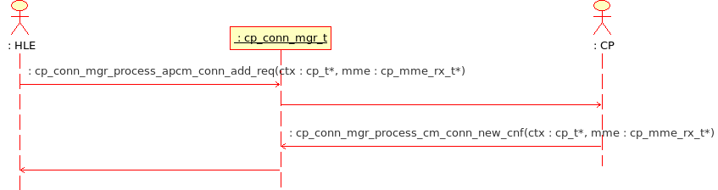Illustration 2.2: Process - Originating STA - new conn req

The connection module shall process the request of the HLE to send a MME transmitting the connection request to the other(s) STA.
The request ID shall be stored.
The connection module receives the confirmation of the terminating STA and relay the information to the HLE, sending a MME with the request ID.
If the connection is accepted by all the STA the HLE will transmit the data flow. If they are not all accepting it the originating STA shall send to each terminating STA a release request (CM_CONN_REL.REQ). The connection shall also be removed.

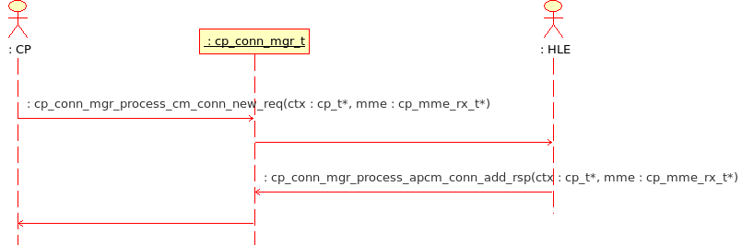Illustration 2.3: Process - Terminating STA - new conn req

When a STA receives a connection request it tests if the number of connections of the STA has been reached or not. If not, it transmits the request to the HLE. The connection shall be initiated and a LLID-R chosen.
The HLE will send its response that will be transmitted to the originating STA. If the response is negative the connection shall be removed.

Release of a connection
The release of a connection can come from :
- A request from the HLE
- A CSPEC problem
- A connection creation problem
The HLE shall request to the connection module to release a connection (APCM_CONN_REL.REQ). The connection module then shall transmit to the terminating STA the release indication (CM_CONN_REL.IND).
At the reception of the MME the terminating STA shall transmit the message to the HLE (APCM_CONN_REL.IND). It also shall remove the connection from its list.
The terminating STA will respond to acknowledge the release of the connection (CM_CONN_REL.RSP). The originating STA shall remove the connection from its list at the reception of this MME.
The connections have to be monitored. If the CSPEC is not respected it shall release the connection.
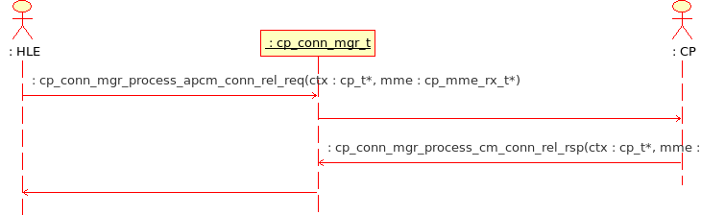Illustration 2.4: Process - Originating STA - rel req

Modification of a connection
If the HLE changes the CSPEC the connection module shall modify its connections (APCM_CONN_MOD.REQ).
For the local links it shall send a CM_CONN_MOD.REQ to the STAs involved in the connection. They will respond with a CM_CONN_MOD.CNF saying if they agree to this change. If they do the connection won't be modified, only the CSPEC will be updated if they don't the connection will be torn down. The release of the connection shall be managed by the originating STA at the reception of a failure into the confirmation of a terminating STA.
For the Global links (see the CCo action document) the STA shall notify the CCo of the change of CSPEC. The CCo shall then take care of the protocol mechanism to alert and modify the connection.
A confirmation with the result will be received by all the STA signifying the new connection state.

Information of a connection
This MME has no real purpose into the protocol it is not triggered by anything. It asks informations concerning a specific connection.
The STA targeted will send the data concerning its connection.

Test the validity of a connection
Study the validity of the connection's CSPEC
Need :
CP context
CID

Return : result of the validity checking (values described)
u8
cp_cco_action_conn_validity(cp_t *ctx, cp_cid_t cid);

Result | Reason
0x00 | Valid
0x01 | insufficient CSPEC
0x02 | Max number of link reached for this STA
0x04 | Link already exist with this CID

References
REF1 : Home Plug AV
File:
revision 1.0.10

History

Revision | Date | Comments
A0 | 2008/03/11 | Creation

Internal History

Rev. | Date | Comments | Customer  Revision
A0 | 2008/03/11 | Beginning of the Specification.

